**Quick Guide to Creative Commons**

**Creative Commons licences** work as “Some rights reserved” rule instead of “All rights reserved” rule. **CC** offers a diverse set of license conditions – the freedoms and limitations. This allows authors to define rules on which they would like to share their creations with others. At the same time users gain more rights to the use of their works.

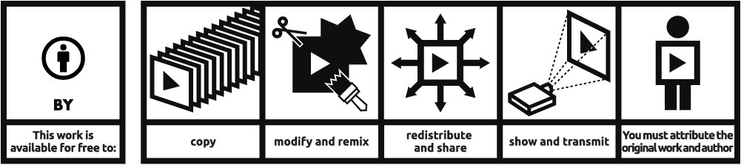

**Attribution 4.0** – This license lets others distribute, remix, tweak, and build upon your work, even commercially, as long as they credit you for the original creation. This is the most accommodating of licenses offered. Recommended for maximum dissemination and use of licensed materials. <http://creativecommons.org/licenses/by/4.0/>

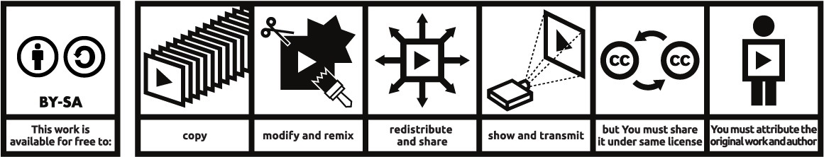

**Attribution-ShareAlike 4.0** – This license lets others remix, tweak, and build upon your work even for commercial purposes, as long as they credit you and license their new creations under the identical terms. This license is often compared to “copyleft” free and open source software licenses. All new works based on yours will carry the same license, so any derivatives will also allow commercial use. This is the license used by Wikipedia, and is recommended for materials that would benefit from incorporating content from Wikipedia and similarly licensed projects. <http://creativecommons.org/licenses/by-sa/4.0/>

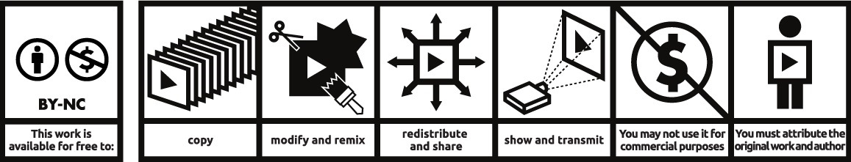

**Attribution –NonCommercial 4.0** – This license lets others remix, tweak, and build upon your work non-commercially, and although their new works must also acknowledge you and be non-commercial, they don’t have to license their derivative works on the same terms. <http://creativecommons.org/licenses/by-nc/4.0/>

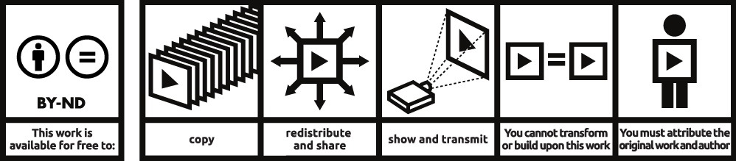

**Attribution – NoDerivs 4.0** – This license allows for redistribution, commercial and non-commercial, as long as it is passed along unchanged and in whole, with credit to you. <http://creativecommons.org/licenses/by-nd/4.0/>

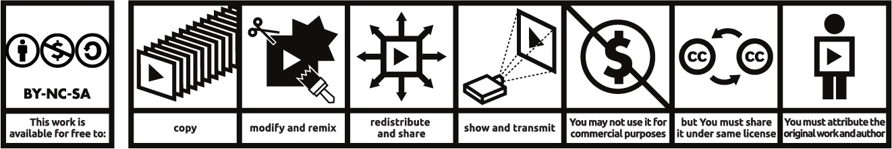

**Attribution-NonCommerical-ShareAlike 4.0** – This license lets others remix, tweak, and build upon your work non-commercially, as long as they credit you and license their new creations under the identical terms. <http://creativecommons.org/licenses/by-nc-sa/4.0/>

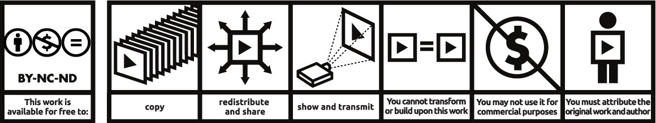

**Attribution-NonCommercial-NoDerivs 4.0** - This license is the most restrictive of our six main licenses, only allowing others to download your works and share them with others as long as they credit you, but they can’t change them in any way or use them commercially. <http://creativecommons.org/licenses/by-nc-nd/4.0/>

This is an adaptation of the poster [Open poster about CC licences](http://creativecommons.pl/2012/06/open-poster-about-cc-licenses/) by Creative Commons Poland, available under a [Creative Commons Attribution 3.0 Poland licence](https://creativecommons.org/licenses/by/3.0/pl/deed.en).

This Quick Guide to Creative Commons is created by National Copyright Unit, COAG Education Council and available under a [Creative Commons Attribution 4.0 International Licence](http://creativecommons.org/licenses/by/4.0/).

[Creative Commons License](http://creativecommons.org/licenses/by/4.0/)